

The last teaching week of Semester one. That’s where we are, it’s where we’ve arrived after all this time. Congratulations to all of you, for it has been a long and often difficult semester, but one which we at Billitin productions © hope you enjoyed. With all that, it is also time to put your collective heads down and study/procrastinate/claim the world has ended and give up. So good luck to all of you!

*Doing it for Bill since 2014*

THE BRUCE BILLITIN

**ISSUE 14: Monday 23rd May - Sunday 29th May**

*Doing it for Bill since 2014*

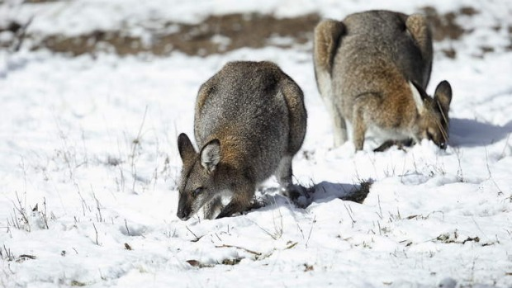

These kangaroos seem to be enjoying the cold, and so will you when it hits -1 on Tuesday night

CANBERRA WIND SYMPHONY: BLOWN AWAY

**25th May 7:30pm The Street Theatre**

The International Canberra wind symphony presents music created by the finest writers, highlighting the unique sounds capable of being produced by these instruments. As well as this, for each ticketed performance, a substantial donation is made to beyondblue to aid in tackling depression in farmers, so why not support this group?

NATIONAL CAPITAL RALLY  
**27th-29th May Westside Acton Park**

Canberra’s largest motorsport event is coming to town this weekend in the Westside Acton park down the road in New Acton. Starting at 5pm on Friday rally cars will be doing laps around park, with multiple areas for spectators, the ceremonial start of the event. If you would like a true forest rally experience, multiple spectator points are available over the weekend in Kowen Pine Forest, where the races will be held over the weekend. You can find details as to the spectator spots, competitors and timing of all the events at:  
http://nationalcapitalrally.com.au/

Check it out!

YOU, YOUR FRIEND & MENTAL HEATH

**24th May 8pm, BN Room**

Andrew Staniforth from ANU counselling is coming to Bruce to talk to us about those difficult conversations in which a friend approaches you about a serious issue, mental health related or otherwise, that they are dealing with. This will be accompanied by an open discussion, food and tea/coffee. A link to signups can be found on Banter and Ressies, and this is a great event for everyone!

ANUSA’S LESS STRESSTIVAL

**All week + Stuvac, various locations**

Feeling stressed? Feeling worried about exams? Or could you just not give a flying **** ? If you said yes to any of the above, then ANUSA is here to help. They are holding a bunch of destressing activities over the next few weeks to look after all of us, including;

* Kitten Play Dates
* Carnival rides
* Sumo Suits
* Horizontal bungee
* Free Hot chocolate
* More!

For more details head to www.anusa.com.au/less-stresstival/



*I need my sleep. I need about eight hours a day, and about ten at night*. – Bill Hicks



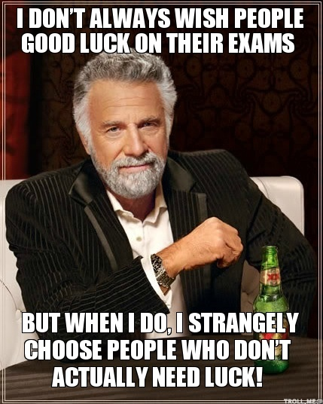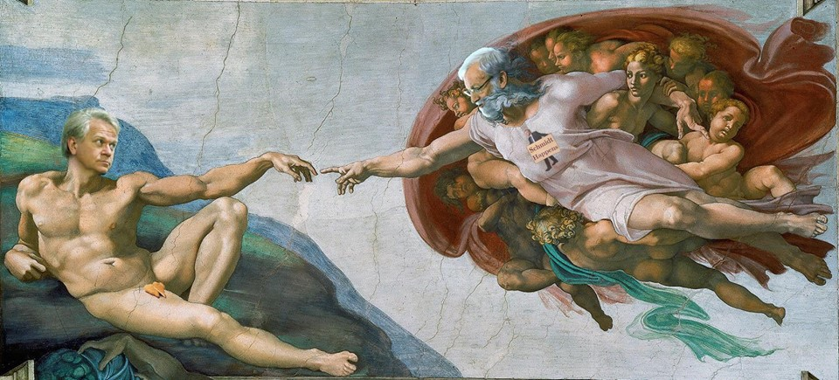

EXAM PERIOD ACCORDING TO ANU

STALKERSPACE

**Exam period is a tough time for all and one which is sure  
to have its ups and downs, however it is one we can all get**

**over with the help of good advice. And what better place  
 for that advice than the most rational, free-spoken, open-minded and wise forum on the internet? Through careful analysis of the content and meaning behind all those posts, your Billitin team has collated this series of tips which are sure to get you through the tough times ahead.**

**Exams are the worst time in your life. Period.**   
Forget funerals, don’t worry about those pesky breakups or trivial terminal illnesses, exams are definitely by far the worst. Therefore the only way possible to get through this is through the guaranteed method of curling up in a ball and going to sleep, or by following the next piece of advice…

**Cram**

There’s knowledge in your books. And then there is knowledge in your head. Clearly you can’t possibly have had time to study or work this semester and put out consistent notes to ensure that you would have the best chance of succeeding come exam time. No, that’d be stupid. So the only viable solution is to grab fistfuls of that knowledge and cram it into your head. Read those words till your eyes hurt, and it says its 6am on the clock, let your cranium expand, and, according to one knowledgeable memester, sometimes it may be even necessary to eat the textbook.

**Panic**

What other reasonable response is there in these horrible, life threatening circumstances than to panic? I mean obviously there is no chance that you’d have actually done the work. So accordingly its time to pack your bags, say so long to your grades and head off to that lovely place where exams and hard work are apparently not a thing, UC.

**Make memes**

Now that your dreams of getting a real job have failed, the only remaining thing to do is resign yourself to a life of making and posting memes all over the internets. ANU stalkerspace holds this career path in high regard, so why shouldn’t we, with the inspirational motto, ‘make memes, not dreams’ leading the way in this cutting edge field. However, there is one other option…

**Don’t stress, You will be Fine**

This one wasn’t taken from Stalkerspace, but rather from our own experience at the  
Billitin, so maybe take it with a grain of salt. Exams aren’t the end of the world, they   
are piece of paper, and while they may be important, try not to stress too hard. Take a  
break every now and again, make sure to look out for yourself and your friends, and  
just remember that everyone else is going through something similar.   
So on that note, the Billitin wishes you all good luck!



TRIVIA

1. What is the only country part of the UN which is not also 6. In what ocean are the British Virgin Islands located?  
 part of the WHO? 7. Who wrote the screenplay for ‘Fantastic Beasts and Where

2. What is the alcoholic ingredient in a Mojito cocktail? To Find them’?

3. In which country is the Suez Canal located? 8. Who is the world’s highest paid actor?

4. What rugby 7’s team is Jarryd Hayne currently playing 9. What type of jelly is Vaseline?  
 for? 10. How many African countries end in the letter ‘I’?

5. In what language were most of Mozart’s opera’s written?

1. Liechtenstein, 2. Rum, 3. Egypt, 4. Fiji, 5. Italian, 6. Atlantic Ocean, 7. J.K. Rowling, 8. Robert Downey Jnr, 9. Petroleum Jelly, 10. Four (Burundi, Djibouti, Malawi and Mali)